**Project Design Phase**

**Problem – Solution Fit Template**

|  |  |
| --- | --- |
| Date | 23 June 2025 |
| Team ID | LTVIP2025TMID56697 |
| Project Name | LearnHub: Your Center for Skill Enhancement |
| Maximum Marks | 2 Marks |

**Problem–Solution Fit Template: Online Learning Platform (OLP)**

**Definition**

The Problem–Solution Fit in the context of the Online Learning Platform (OLP) means identifying the real learning struggles faced by students and offering a solution that directly and effectively addresses those problems—enabling flexible, engaging, and accessible learning

**Purpose:**

✅ Solve real-world learning challenges for students such as lack of access, rigid schedules, expensive courses, and uninspiring content with a modern, interactive platform.  
✅ Accelerate user adoption and success by offering features like self-paced learning, certifications, and mobile accessibility—meeting learners where they are.  
✅ Enhance communication and marketing by understanding student pain points and targeting messages (e.g., “Learn anytime, anywhere” or “Certified skills at your own pace”) that resonate with real needs.  
✅ Increase user engagement and retention by removing barriers (cost, access, support) and building trust through consistent value delivery (e.g., progress tracking, live sessions, certifications).  
✅ Understand the student’s current learning experience, whether traditional or digital, and improve it with technology, intuitive design, interactivity, and practical outcomes.

**Template:**

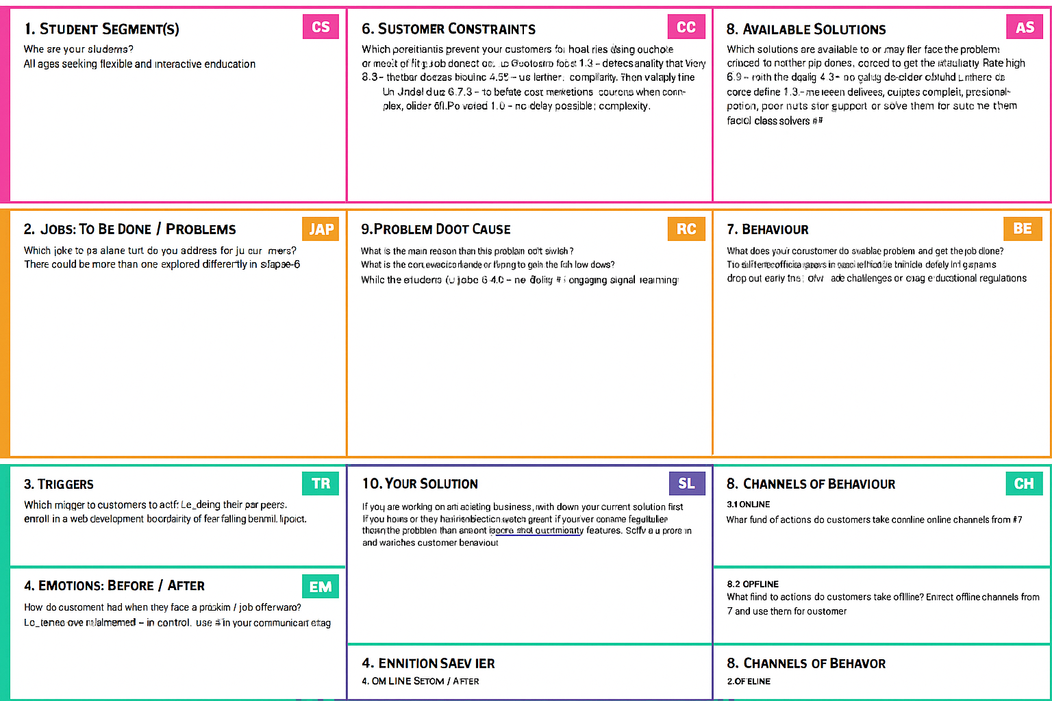

References:

1. <https://www.ideahackers.network/problem-solution-fit-canvas/>
2. <https://medium.com/@epicantus/problem-solution-fit-canvas-aa3dd59cb4fe>